PROFESSIONAL PROGRAMMING TRAINING CENTER



PROJECT DOCUMENT
Project Name:

Course: Professional Programmer
Group:
- Trần Võ Minh.
- Lâm Ngọc Huy

Trainer: Đỗ Phú Thiện

Danang,

PREFACE

THANK YOU
During the graduation project, I received a lot of helps, comments and enthusiastic advices from teachers. I would like to express my sincere thanks to Mr. Do Phu Thien, the guider of the courses who enthusiastically guided and instructed us throughout the course of the thesis, helping me to have a theoretical basis. steadily and create conditions to help us improve in the whole learning process. Finally, We would like to sincerely thank our family and friends, who have always created favorable conditions, cared for, helped and encouraged us during our studies and completed the graduation thesis.
TABLE OF CONTENTS

1. Introduction 3
2. The reasons to implement this project 3
3. Solution Document 3
4. Analysis Document 3
5. Design Document 3
6. User Guide 4
7. Management Methods 4
8. Conclusions and expand 4
9. References 4

1. Introduction
[This section is included:
- Project name and short description:
- Objectives:
- Brief of requirements.
- Scopes]

- Topic name: PC Airlines online booking and management system.
- The project of "PC Airlines online flight booking and management system" of our group aims to support the Aviation Administration Department and its customers handy in managing and using the services of aviation, in which:
- For aviation management staff:
+ Easily manage flight information such as passenger and aircraft information, seat number, flight status, possible incidents.
+ Update and organize flights, flight routes and promotions clearly and logically, store information of organized flights for easy revenue statistics or security purposes.
+ Can search and access flight data, customer information, information about customer incentives for easy consultation and customer support.
- For customers:
+ Having online transactions easily, searching and tracking flights.
+ Book tickets, pay for tickets online by credit card.
+ Suitable for all customers with easy to use and popular interface.
- This application helps the aviation management department to manage flights, customers and manage revenues and expenditures effectively. As it is developed, users can conveniently register, book tickets, view vacant seats or flights. The application provides an eye-catching interface for users to easily access and get used to.
- Main functions of the product:
System administration functions: Login, Edit, Log out.
Flight management function: set up flight schedule, Operations (add flights, modify flights, delete flights), look up flights, operations (look up flight information)
+ Online booking function: search for tickets, search for available flights, book tickets, pay online
The feasibility and usability of the product: Currently, with the continuous development of science and technology, it is no longer difficult to build such aircraft management applications. Along with the strong advancement of the information technology industry in the 4.0 era, it will help programmers have many resources, support libraries, means and environment to help projects succeed in the shortest time.

2. The reasons to implement this project
[This section is included:
- List of the reasons to implement this project.
- The theory bases.
- Practices studies.
- The 21st century is the century of information technology explosion, advanced technologies have developed rapidly. Besides, the world is in the trend of modernization, all of which are meant for integration. Now, businesses and government not only compete with businesses in one country, but also with businesses and governments around the world.
- In the context of the strong development of the Internet in general, e-commerce and e-government in particular, the application of information technology to the service sector is not new in the world, but new in Vietnam. Many problems are raised to bring customers the best, most convenient and effective services. Therefore, the topic "Building an aircraft system management application" of our group wants to build a system to help companies and transaction centers reduce personnel and telecommunications costs, shorter support time in the management of air ticketing systems, accurate support information as required and does not miss customer requests.
- The project is built and developed by two members: Tran Vo Minh and Lam Ngoc Huy with the help of lecturers working at the Iviettech Professional Programmer Training Center. The members of the group are currently students of PR32 class, the professional programmer training course at the center. After receiving information about the Project subject in the curriculum, we decided to form a group. After the first meeting of the group, the members agreed and selected the topic "BUILDING ONLINE AIRCRAFT MANAGEMENT APPLICATION AND BOOKING" for the group's project.

3. Solution Document
[This section is included:
- Solution Architecture: picture and description.
- Technical element like hardware, software, framework to implement this solution.
- we utilized all the useful languages and technologies to support us to build this project such as HTML5, CSS, Bootstrap, Javascript, Jquery, Ajax, Java, Spring boot…
- Data is organized and stored in MySQL Database System.





4. Analysis Document

[Using Use Case Diagram to analysis the system]

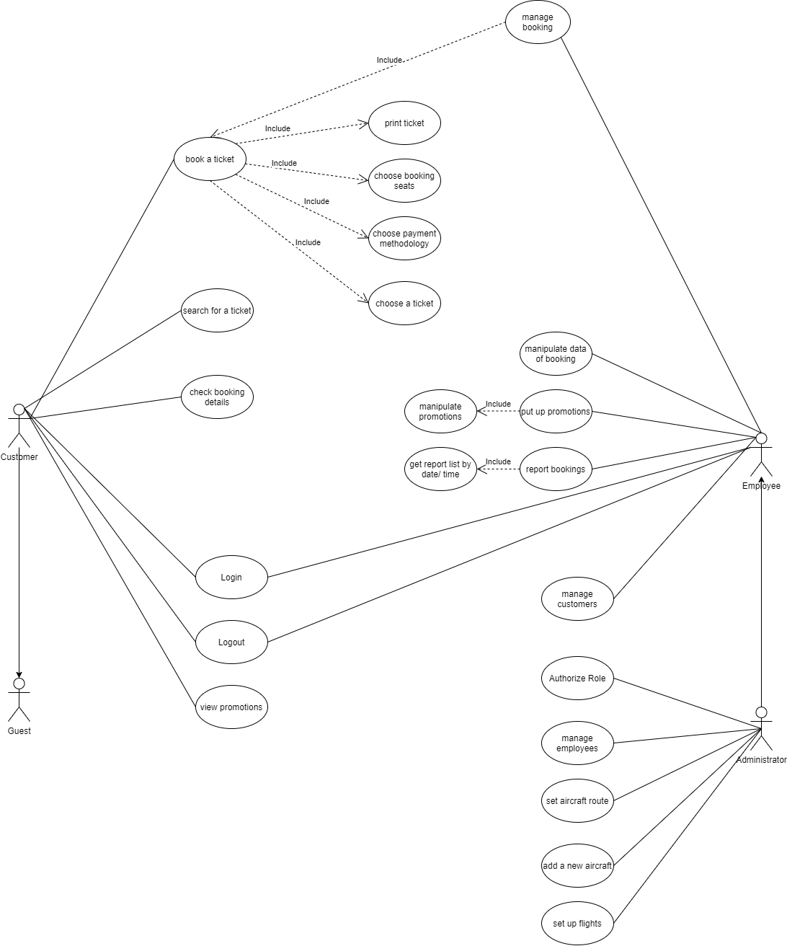

5. Design Document

5.1 UI Design
[Describe the structure of the interface and a few wire frame of the interface]
5.2 Database Design
[Describe ERD and specify the data on the tables as the field name, size, type of data …]
5.3 Function Design
[Build Class Diagram, Activity Diagram, Component Diagram and Deployment Diagram... to describe of function detail.]

6. User Guide
[List main steps to setup and use system]

7. Management Methods

[Specify management methods used to run projects, description of members, their roles and the project plan.]

8. Conclusions and expand
[Specify what to do, what not to do and can be expanded in the future. Lesson learnt you have got in this project]

9. References

[Serial number ] Document name, Author, Publisher, Publish year ]

